

Documented by: Kevin Ma, Joseph Harrison Lim, Poulad Ashraf Pour, Mamunur Rahman on 09/15/2018

# What is Nextcloud?

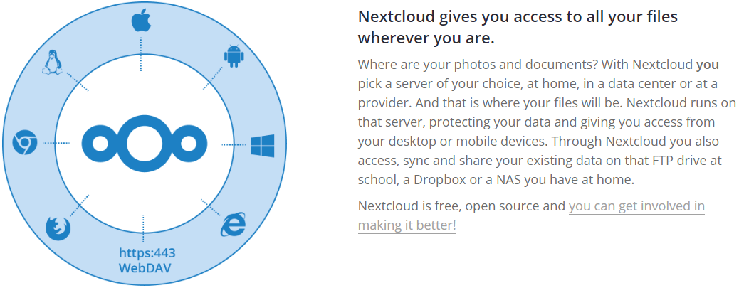

# Why Nextcloud?

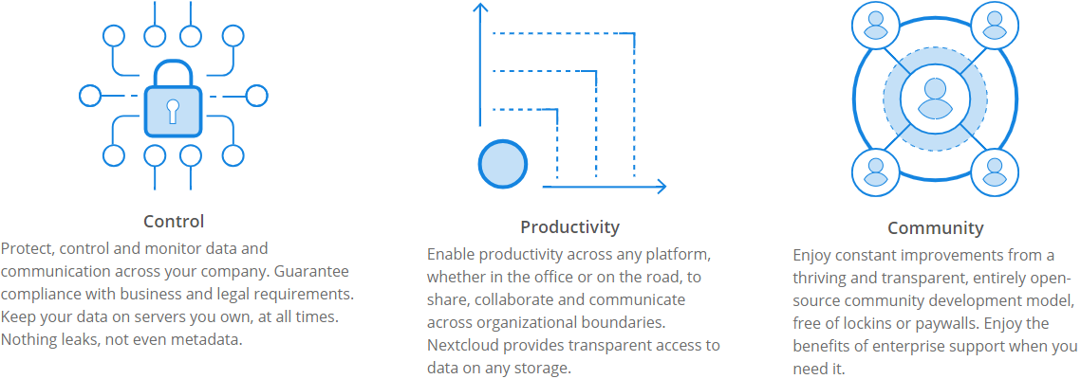

# Nextcloud Server Setup

To install and setup Nextcloud, you will need to have a few pre-requisites.

## Pre-requisites

1. Oracle VirtualBox
2. Virtual Machine running Ubuntu Server (recommended 18.04.1 LTS)
3. Snappy Netcloud (<https://github.com/nextcloud/nextcloud-snap>)

## Snappy Netcloud

Nextcloud server packaged as a snap. It consists of:

* Nextcloud 13.0.5
* Apache 2.4
* PHP 7.1
* MySQL 5.7
* Redis 4.0
* mDNS for network discovery

## How to Install

1. Download the latest version of Oracle VirtualBox from <https://www.virtualbox.org/wiki/Downloads>
2. Install Oracle VirtualBox using the GUI installer
3. Download Ubuntu Server 18.04.1 LTS from <https://www.ubuntu.com/download/server>
4. Create a new Virtual Machine in Oracle VirtualBox

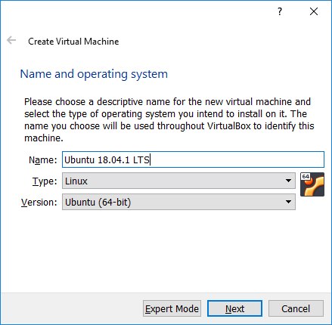

1. Configure the virtual machine
   1. 1024 MB memory
   2. Create a virtual hard disk now (10GB)
   3. Hard disk file type: VDI (VirtualBox Disk Image)
   4. Storage on physical hard disk dynamically allocated (only use space as it fills up, up to maximum fixed size (will not auto shrink when space freed)

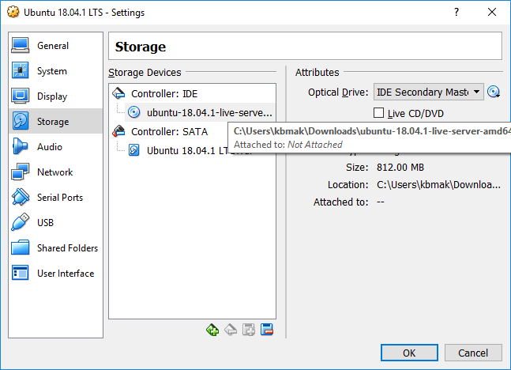

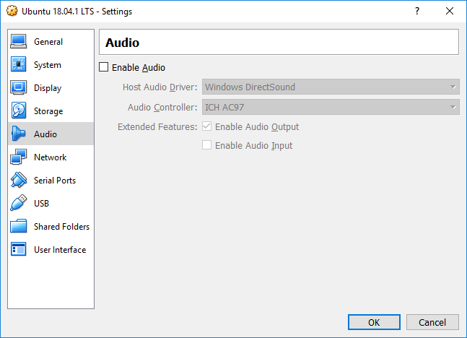

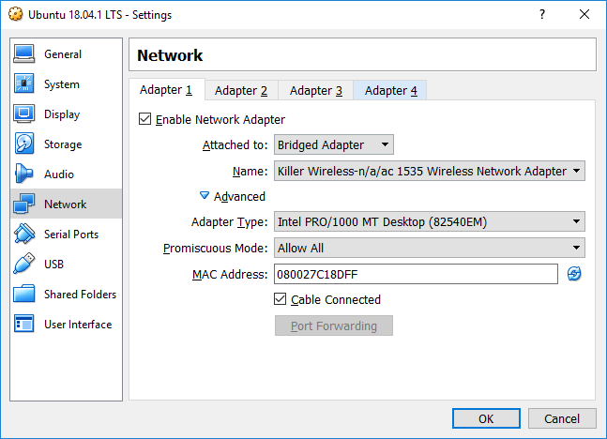

1. Turn on the virtual machine and Install Ubuntu Server by following the on-screen instructions (use default options when prompted).

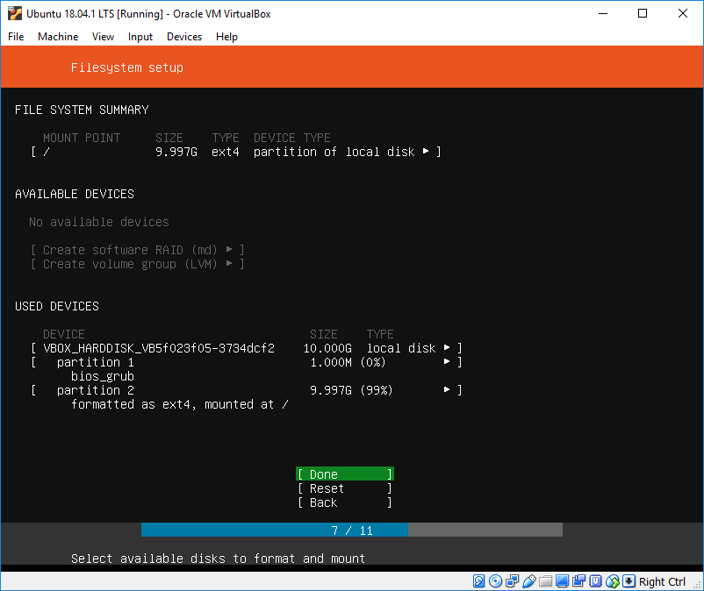

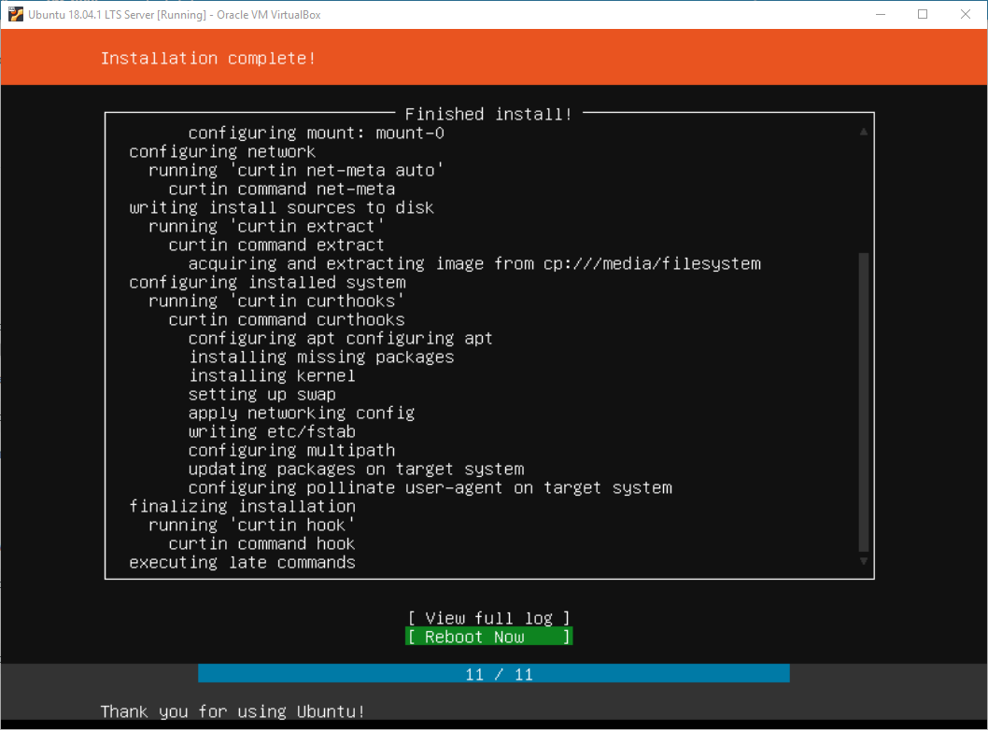

1. Reboot the virtual machine when installation is complete
2. SSH into the VM using the IP address displayed when the VM reboots (we like to use our own terminals instead of the clunky Oracle VirtualBox terminal)

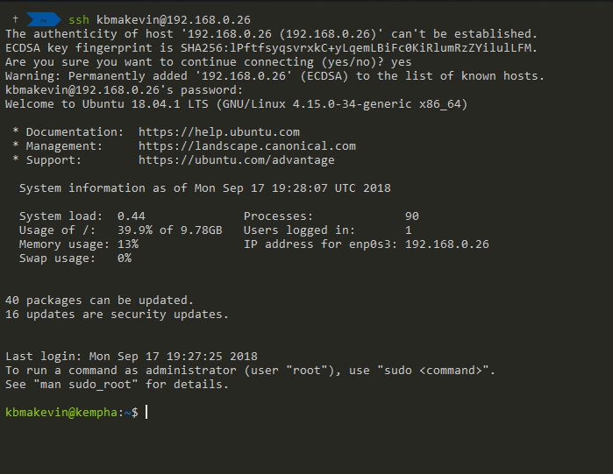

1. Install snapd by entering the following command in the terminal:

***sudo apt install snapd***

1. This Nextcloud snap is available in the store for release. Install via the command:

***sudo snap install nextcloud***

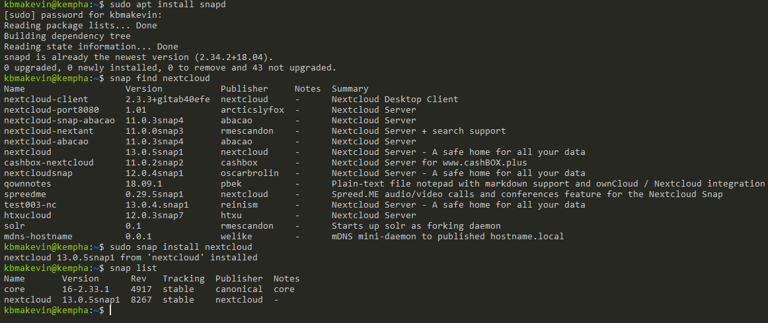

1. Visit the ipaddress of your virtual machine in your favorite browser to finish the setup of Nextcloud. Upon visiting the Nextcloud installation for the first time, you'll be prompted for an admin username and password.

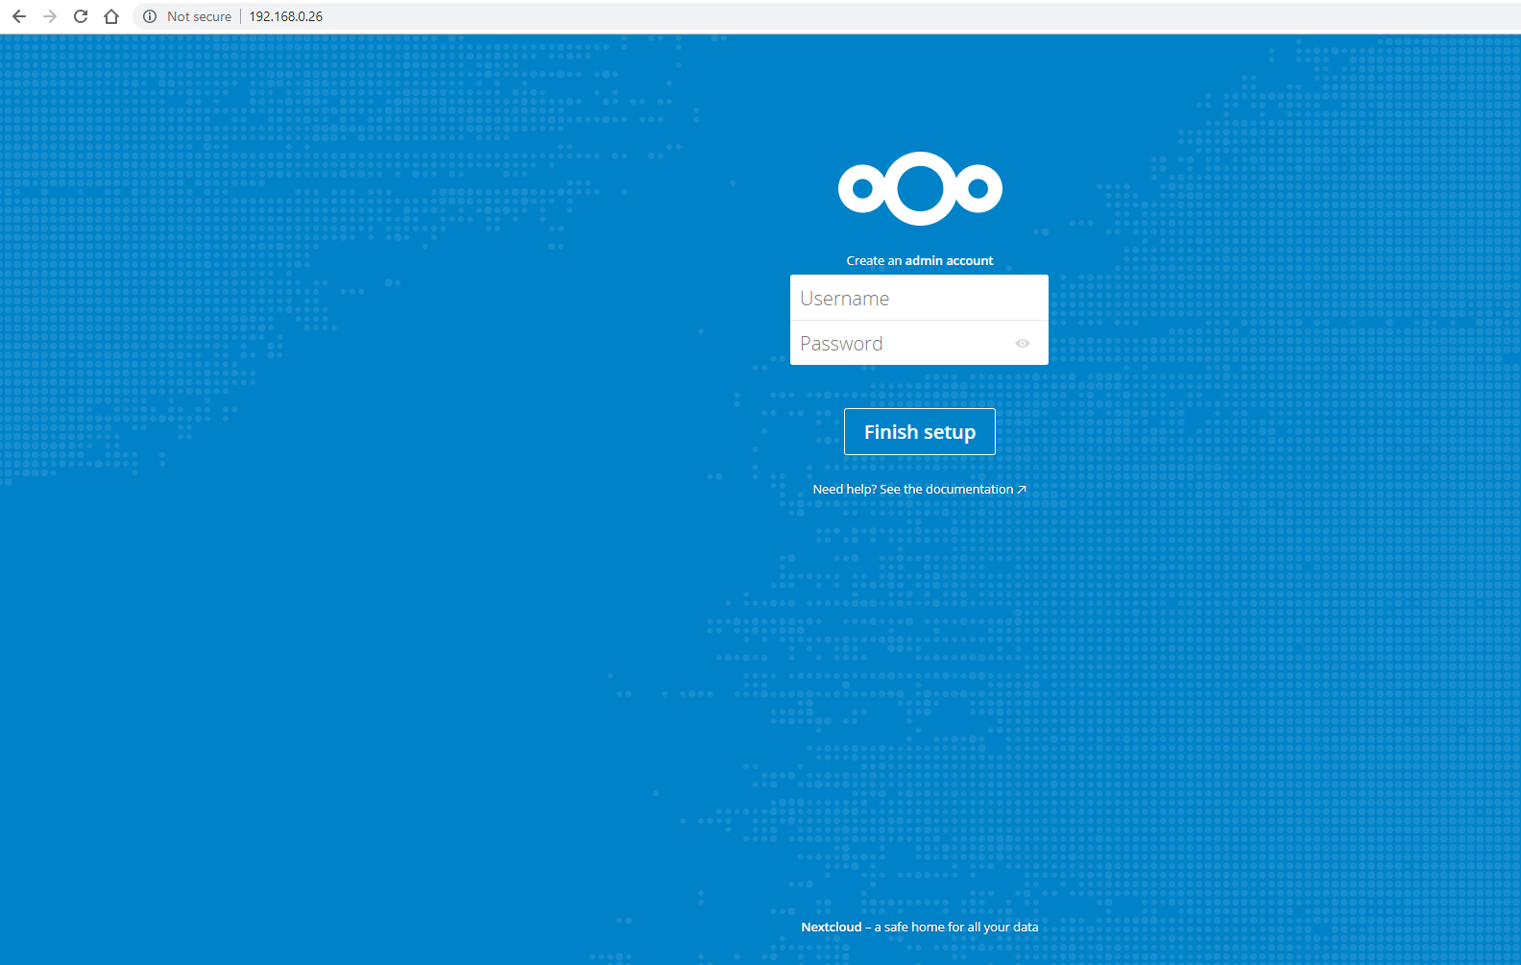

1. All done! Now you are free to explore the many fascinating features of Nextcloud (able to create users, install apps, and upload files, and much more)! Enjoy 😊!

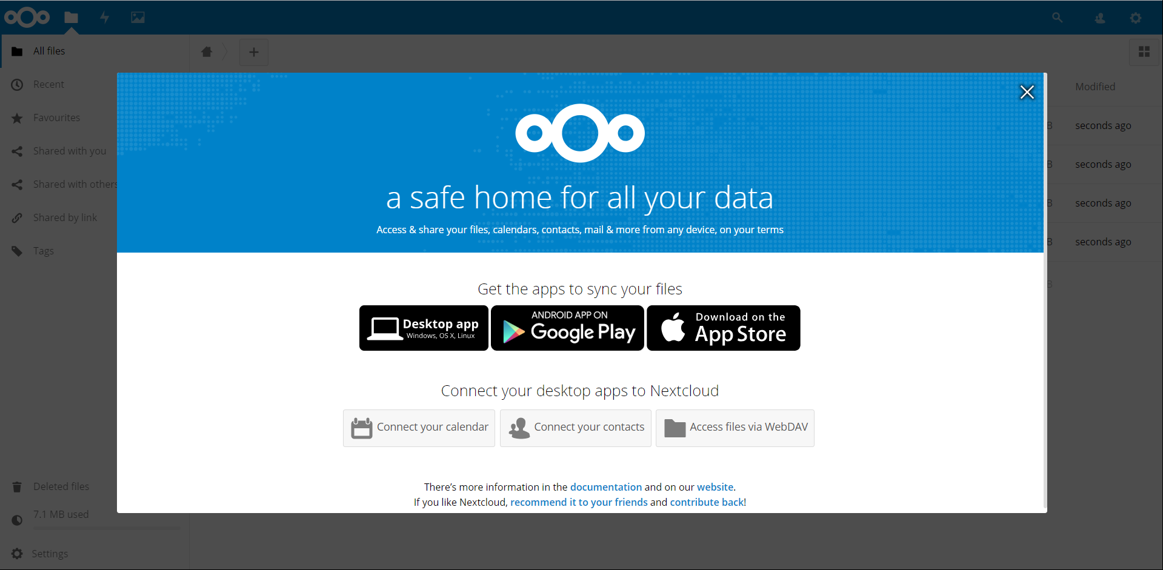

# Nextcloud Client Setup

1. Install Nextcloud clients (Desktop, Mobile) by downloading from <https://nextcloud.com/install/#install-clients>

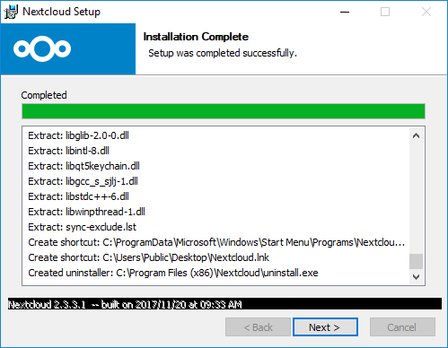

1. 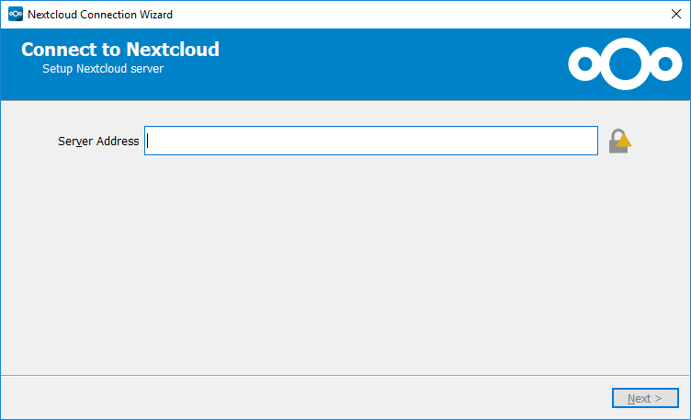
2. 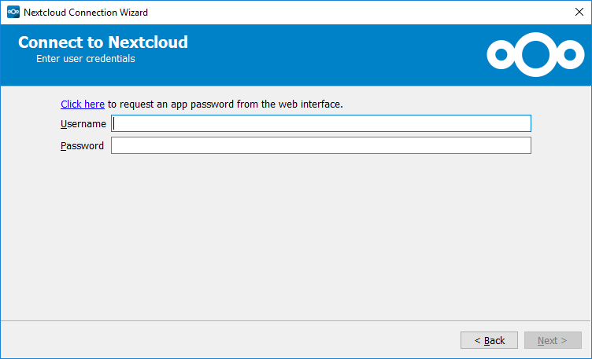
3. 